Single Adjust Side Release Buckles
Side release buckles are one of the most versatile buckles available
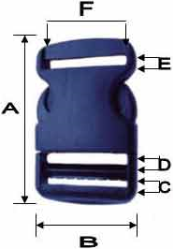
Size | A | B | C | D | E | F
1 inch | 2.68 inch | 1.28 inch | 0.14 inch | 0.17 inch | 0.15 inch | 1.10 inch
1 ½ inch | 2.74 inch | 1.84 inch | 0.17 inch | 0.19 inch | 0.20 inch | 1.50 inch
2 inch | 2.87 inch | 2.34 inch | 0.16 inch | 0.18 inch | 0.22 inch | 2.01 inch

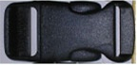
Figure 1.1: 1 inch single adjust side release buckle
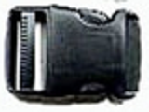
Figure 1.2: 1 ½ inch single adjust side release buckle
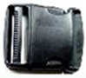
Figure 1.3: 2 inch single adjust side release buckle

Flat Nylon Webbing
Flat nylon webbing is great for high abrasion applications, or for use with larger buckles with higher breaking strengths. It is ideally suited for leashes, collars, leads, ratchet straps, D-ring belts, etc. Flat nylon has a breaking strength of 3,500 lbs., so it works great for medium to heavy duty applications.

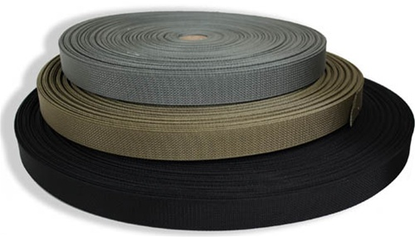
Figure 2.1: Flat Nylon Webbing

Acetyl Plastic Strap Adjusters
Strap adjusters are very versatile buckles. Frequently used in backpacking straps and on day back shoulder straps. They are also used as a light to medium duty utility strap.
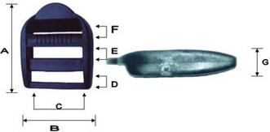
Size | A | B | C | D | E | F | G
1 inch | 1.53 inch | 1.28 inch | 1.01 inch | 0.18 inch | 0.21 inch | 0.15 inch | 0.30 inch
1 ½ inch | 2.13 inch | 2.00 inch | 2.52 inch | 0.18 inch | 0.32 inch | 0.20 inch | 0.46 inch
2 inch | 2.89 inch | 2.41 inch | 2.01 inch | 0.18 inch | 0.35 inch | 0.31 inch | 1.00 inch

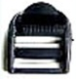
Figure 3.1: 1 inch acetyl plastic strap adjuster
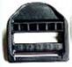
Figure 3.2: 1 ½ inch acetyl plastic strap adjuster
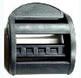
Figure 3.3: 2 inch acetyl plastic strap adjuster

